When choosing a picture, students do not know exactly what picture they will get. They must choose a number (1, 2, or 3). Partner B is specifically told not to show their partner the picture until it is time to start that trial.
Scary Picture 1: A great white shark.
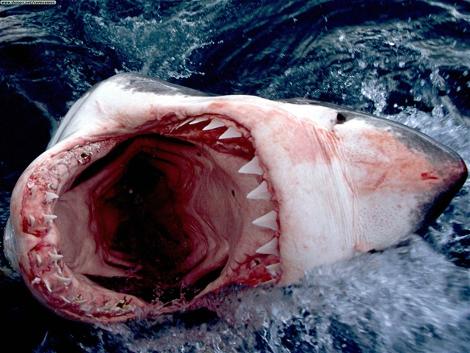
http://3.bp.blogspot.com/-10WPZHUpDyc/Taw-wzB3H0I/AAAAAAAAABo/oFX2IvQs8Q4/s1600/shark+teeth.jpg

Scary Picture 2: Nosferatu’s Shadow. (I would put a picture of the face, but I personally got scared and my heart started beating faster! )
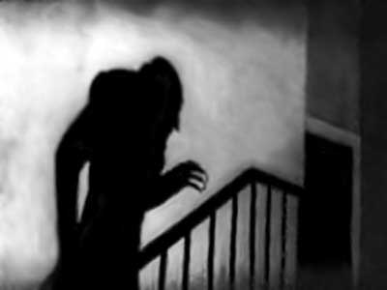
http://horrornews.net/wp-content/uploads/2010/08/Nosferatu-photo-3-400x300.jpg

Scary Picture 3: Lord Voldemort from Harry Potter
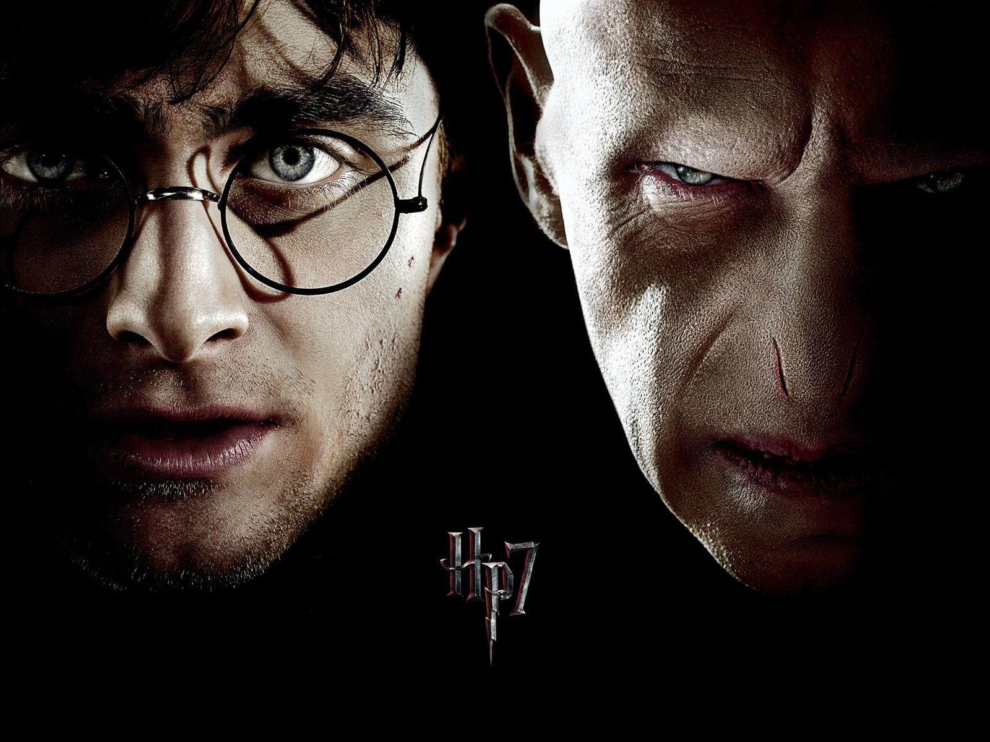

http://burtsystems.co.ug/campuswolox/wp-content/uploads/2011/12/double-harry-potter-voldemort-hp7-1600x12001.jpg

